CHAPTER THREE

SYSTEM DESIGN METHODOLOGY

3.1.0 INTRODUCTION

In this chapter, the system design methodology used in carrying out this project is discussed. The system requirement specification will also be outlined in details in this chapter, it entails a detailed components specification of the system being provided by this project. More so, the system design in terms of logical design and physical design will be specified herein. The logical design consists of the various part of the program and how they interact with each other, while the physical design, illustrates the program specification, type of data and its structure.

3.2.0 SYSTEM REQUIREMENT SPECIFICATION
This section clearly states what the result of this project is and should be. This is to be determined by the objectives of the project.
First of all, the result of this project would be a trained machine learning model capable of predicting the likelihood of having a heart disease in an individual given the following details;
- Age
- Sex
- Cp. (Chest Pain type)
  - Value 1: typical Angina
  - Value 2: atypical angina
  - Value 3: non-anginal pain
  - Value 4: Asymptomatic
- Tresbps: resting blood pressure (in mmHg on admission to the hospital)
- Chol: serum cholesterol in mg/dl
- Fbs: (fasting blood sugar > 120 mg/dl)(1 = true; 0 = false)
- Restecg: resting electrocardiographic results
  - Value 0 : normal
  - Value 1 : Having ST-T wave abnormality
  - Value 2 : Showing probable or definite left ventricular hypertrophy by Este’s criteria
- Thalac : Maximum heart rate achieved.
- Exang: Exercise induced angina (1 = yes, 0 = no)
- Oldpeak: ST depression induced by exercise relative to rest.
- Slope: The slope of the peak exercise ST segment.
  - Value 1: upsloping
  - Value 2: flat
  - Value 3: Downsloping
- Ca: Number of major vessels (0-3) colored by flourosopy
- Thal: 3 = normal; 6 = fixed defect; 7 = reversible defect.

The result of the prediction should be:
- 1 (one) indicating the presence of heart disease,
- 0 (zero) indicating the absence of heart disease.

3.3.0 SYSTEM DESIGN
This section explains the concept of how the system is designed in terms of architecture, components and data, to satisfy the specified requirements. This would help a user or researcher to understand the intricacies of the prediction model.

3.3.1 LOGICAL DESIGN

This section describes the abstraction of the structure and features of the prediction model from the various parts of the system such as input and output.

3.3.1.1 INPUT DESIGN

In this project, the main input is the collected data, which is used to train the model. The data is in the form of a structured table, where each column represents the features of the individual. A single column is used to represent the prediction result of the tested individual (i.e. has Heart disease or Not). The details of the individual, which is represented by the feature columns have been described in section 3.3.0.
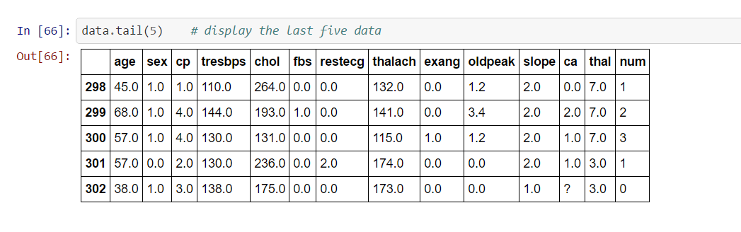
Below is a diagram of the first 20(twenty) rows and last 5(five) rows of the raw data used in this project.
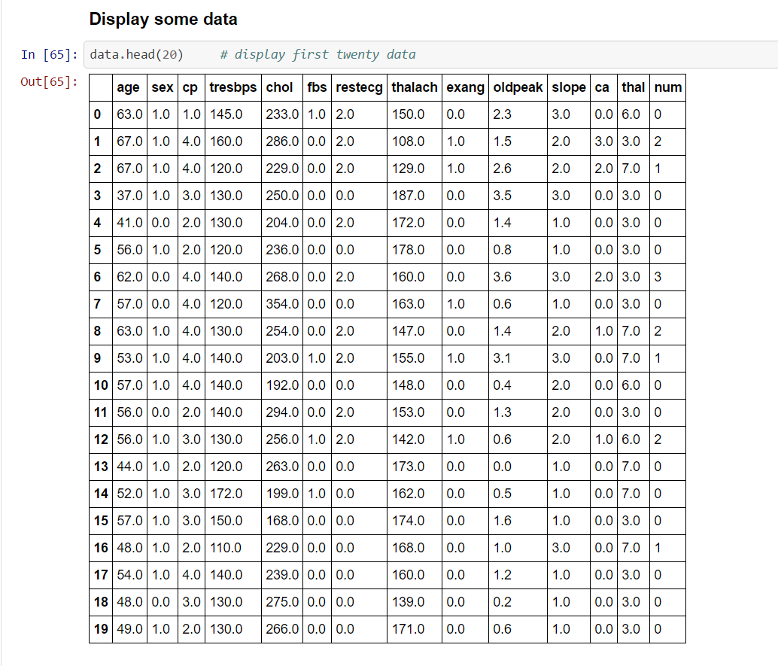

3.3.1.2 OUTPUT DESIGN
The result column (output) is labelled “num” column; it’s values are either 1 or 0, where 1 represent presence of heart disease in the individual, while 0 represents the absence of heart disease in the individual.
3.3.1.3 USE CASE
A typical use case is one where a patient in a hospital is tested and the result of this test is passed to a program that uses the machine learning model to predict the patient’s heart disease status. This is a step forward from expert systems, based on the accuracy of the results.

3.3.1.4 ACTIVITY DIAGRAM

Activity diagram illustrates the various dynamic use case of the system. Below is an activity diagram that summarizes a single use case;
USER’S DATA LOADED INTO THE PROGRAM

FEED THE DATA TO THE MACHINE LEARNING MODEL FOR PREDICTION
DISPLAY THE RESULT TO THE USER

3.3.2 PHYSICAL DESIGN
Physical Design of the system specifies the internal structure of the system. Here, the actual design implementation is demonstrated.
3.3.2.1 PROGRAM SPECIFICATION
The program specification describes the actual logic of the program execution. It defines how the overall system works.
Every machine learning process requires data for training and testing. The quality of the result of a machine learning process is heavily dependent on the data used. Therefore, any successful machine learning process must have a reliable and accurate dataset. To achieve this, a machine learning workflow is used. A machine learning workflow, is an orchestrated and repeatable pattern which systematically transforms and processes information to create prediction models.

In using this workflow, work has been purposely organized into defined tasks and the same workflow can be used to develop solutions to different problems. Before we can use data to create solutions, it must be transformed into the format we can use for processing. Statistical computations are typically done with numbers, therefore, the format of data best suitable for machine learning are numerical data.

The product of the workflow is a prediction solution, which must meet the performance criteria we specify. Herein the performance criteria we have specified is a model that best predict the presence of heart disease in an individual.
The machine learning workflow used involves the following steps:
- Asking the right question.
Asking the right question involves specifying the goal of a machine learning process and to what degree of accuracy the produced model is considered acceptable. In this project, the goal, as specified in chapter one, is to find the most suitable and accurate predictor model for the detection of presence of heart disease in an individual, given the following test results: age (age), sex (sex), chest pain type (cp), resting blood pressure in mm Hg (trestbps), serum cholestoral in mg/dl (chol), fasting blood sugar greater than 120 mg/dl (fbs), resting electrocardiographic result (restecg), Maximum heart rate achieved (thalach), exercise induced angina (exang), ST depression induced by exercise relative to rest (oldpeak), the slope of the peak exercise ST segment (slope), number of major vessels (0-3) colored by flourosopy (ca) and type of defect (thal).
- Preparing the data:
Generally, data to be used in training a machine learning algorithm, must be normalized to standard formats suitable for learning from. The data gotten from the UCI Machine Learning repository, has some nuances that could alter the quality of result of the machine learning process. Steps were taken to get rid of these nuances, and these steps are forms the overall process of preparing data.
III. Selecting the algorithm:
There are numerous machine algorithms in use today, each one is best suitable for a particular task or application. Some are suitable for supervised learning while others are suitable for unsupervised learning. Some of the algorithms work well with results that are continuous data, while others work well with discrete data. In this project, the result, which is “the presence of heart disease” is either true or false. This is a binary classification data therefore a type of discrete or classified data. The algorithms selected and used here are Gaussian Naive Bayes, Support Vector Machines and Logistic Regression which are all capable of predicting classification data.
IV. Training the model:
After selecting the right algorithm, the data is split into two different proportionate parts. One of them is used for training the algorithm and the other is used for testing the model. The training data and its result is passed to the algorithm, it then learns from the data passed to it to create a model based on the data, which will be used to predict similar but unfamiliar data sets.
V. Testing the model:
Testing the model (trained algorithm), involves predicting the result of the test data derived from dividing the data into two parts. Since this test data is new to the algorithm, but the result is known, the prediction made by the model on this test data is compared to the already predetermined results. The outcome of this comparison determines the accuracy of the model.

3.3.2.2 LAYOUT OF TABLES DESIGN AND DATABASE STRUCTURE
This shows the various tables used in the project.
FIELD NAME | DESCRIPTION | VALUES
Age | Age
Sex | Sex | 1 = male, 0 = female
Cp | Chest Pain type | Value 1: typical Angina  Value 2: atypical angina  Value 3: non-anginal pain  Value 4: Asymptomatic
Tresbps: resting blood pressure(in mmHg on admission to the hospital) | resting blood pressure | in mmHg on admission to the hospital
Chol | serum cholesterol | in mg/dl
Fbs | fasting blood sugar > 120 mg/dl | 1 = true; 0 = false
Restecg | resting electrocardiographic results | Value 0: Normal  Value 1: Having ST-T wave abnormality  Value 2 : Showing probable or definite left ventricular hypertrophy by Este’s criteria
Thalac | Maximum heart rate achieved.
Exang | Exercise induced angina | 1 = yes, 0 = no
Oldpeak | ST depression induced by exercise relative to rest.
Slope | The slope of the peak exercise ST segment. | Value 1: upsloping  Value 2: flat  Value 3: Downsloping
Ca | Number of major vessels (0-3) colored by flourosopy | 0 - 3
Thal | Heart rate | 3 = normal; 6 = fixed defect; 7 = reversible defect.
num | Diagnosis of heart disease | 1 = presence of heart disease.  0 = absence of heart disease.

Accept all corrections and address all comments.

